CS4740 Spring 2021 Cloud Computing PA#2

Name: Victoria Wang

UVa User ID: vxw6ta

Instructions: Fill in your answers to the 5 questions and SUBMIT A PDF to collab (along with your code for Question 4)

1. [20 points] After completing the “Before you start” section, cut-and-paste a screenshot (7” wide) showing the status of your “CS4740S21-*your_UVA_ID*” budget. It should look something like this (with a different name and a different budget amount):

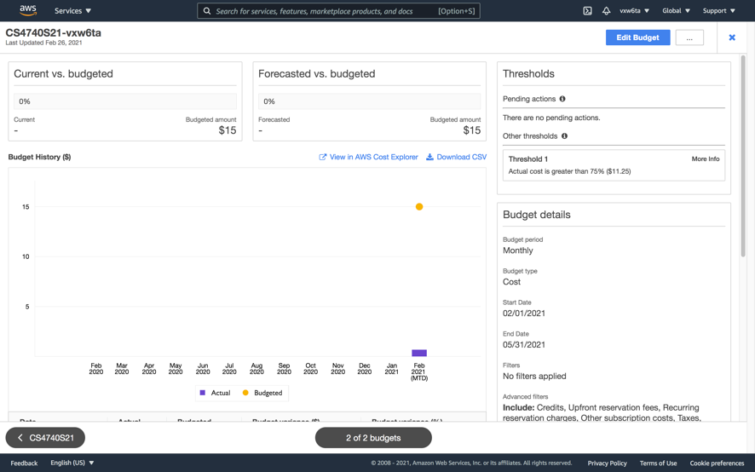

1. [20 points] After completing Part 1 (“Auto-grader Basic System”), cut-and-paste a screenshot (7” wide) showing the execution of autograde.py on the VM, *where it is grading a correct ‘subtract’ submission*. If you were unable to complete this part, explain how far you were able to get and describe the problem (you were unable to debug).

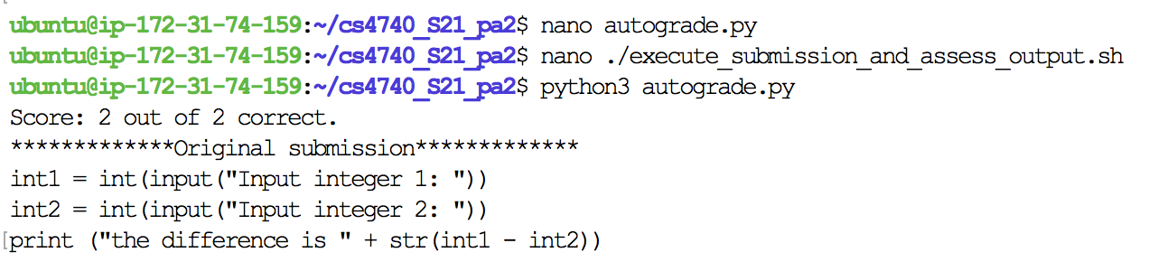

1. [20 points] After completing Part 2 (“Web-based Auto-grader”), cut-and-paste two screenshots (7” wide): [1] the web submission screen, and [2] the results screen (after your autograder has executed). If you were unable to complete this part, explain how far you were able to get and describe the problem (you were unable to debug).

You are required to have a decent User Interface (sufficiently-descriptive Welcome text and instructions on submission page, sufficient results page – if you would be embarrassed to show your boss this, you have probably not done enough!)

**Web Submissions Screen**

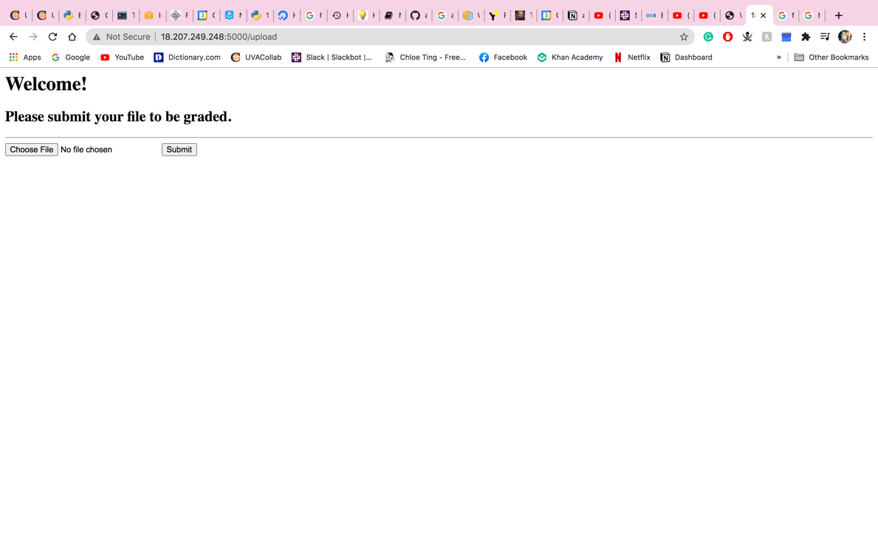

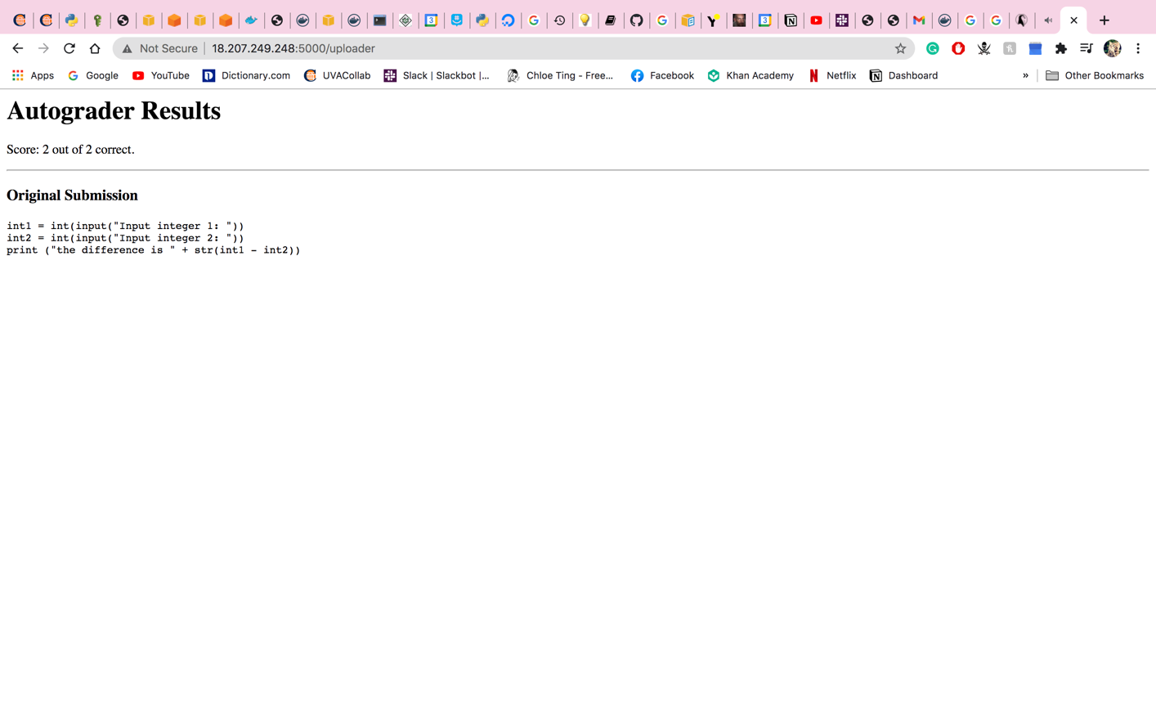**The Results Screen**

1. [20 points] After completing Part 3 (“Docker-based Auto-Grader“), choose one:

✓ I **was able** to successfully complete Part 3, “Docker-based Auto-Grader”

___________ I **was unable** to successfully complete Part 3, “Docker-based Auto-Grader”. Here’s what I got stuck on or here’s why I could not complete it (explain, 5 sentences or less):

Cut-and-paste a screenshot (7” wide) of your system being accessed from your laptop via port 8888.

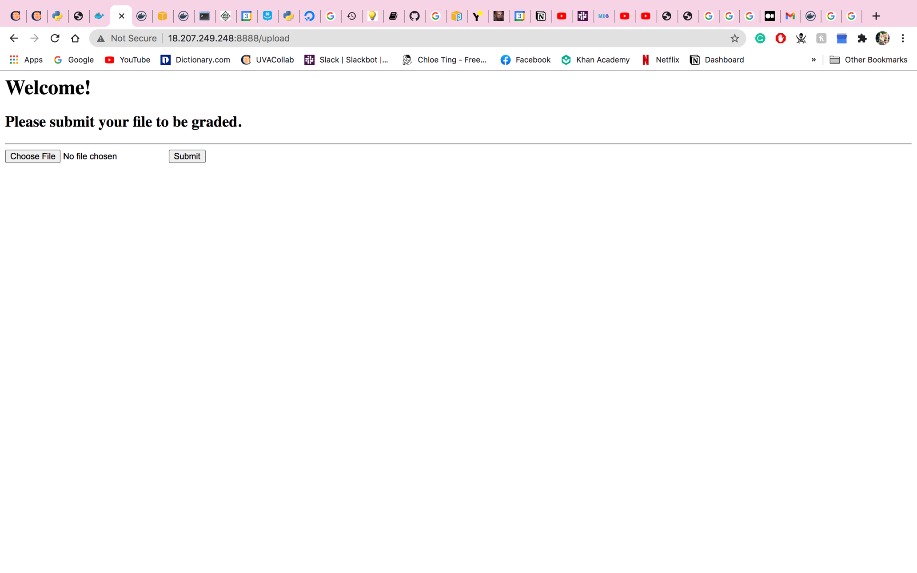

Cut-and-paste a screenshot (7” wide) of your terminal to the VM *after* executing “docker ps” while your service is running.

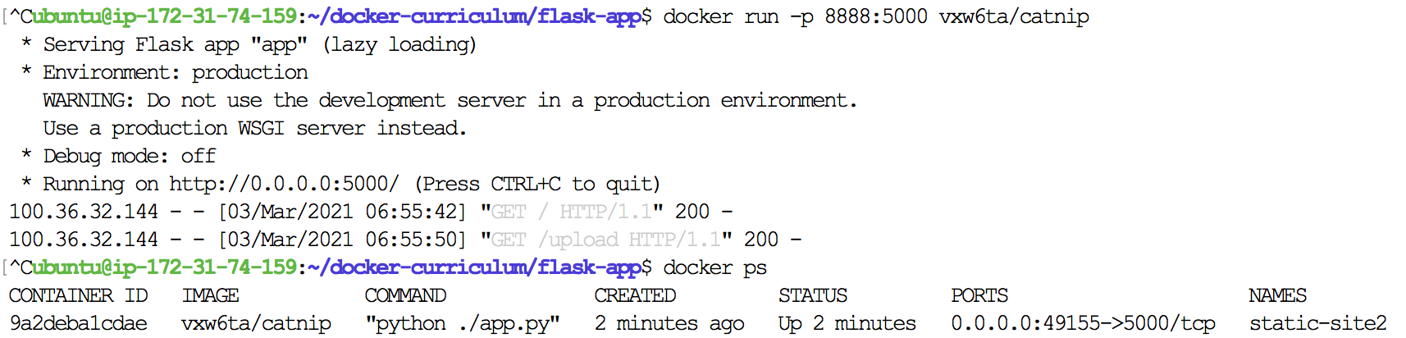

**ALSO attach this source code file to your collab submission (ZIP format). (zip up the directory (and any subdirectories) that would allow a person to run your flask code)**

1. [20 points] After completing Part 4 (“Docker in AWS via Elastic Container Service”), choose one:

✓ I **was able** to successfully complete Part 4, “Docker in AWS via Elastic Container Service”

___________ I **was unable** to successfully complete Part 4, “Docker in AWS via Elastic Container Service”. Here’s what I got stuck on or here’s why I could not complete it (explain, 5 sentences or less):

If you successfully completed, cut-and-paste

[a] the AWS screen (7” wide) showing your service in ECS – e.g., <https://console.aws.amazon.com/ecs/home?region=us-east-1#/clusters/default/services/custom-service/details>

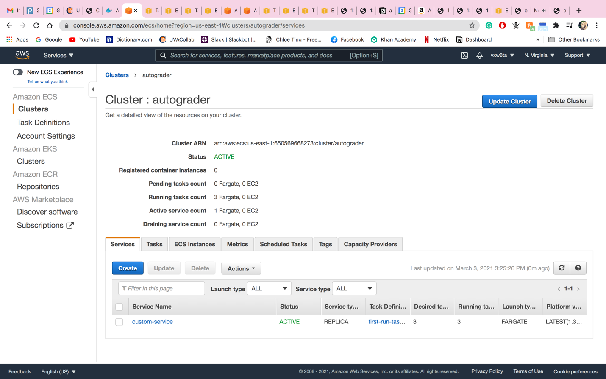

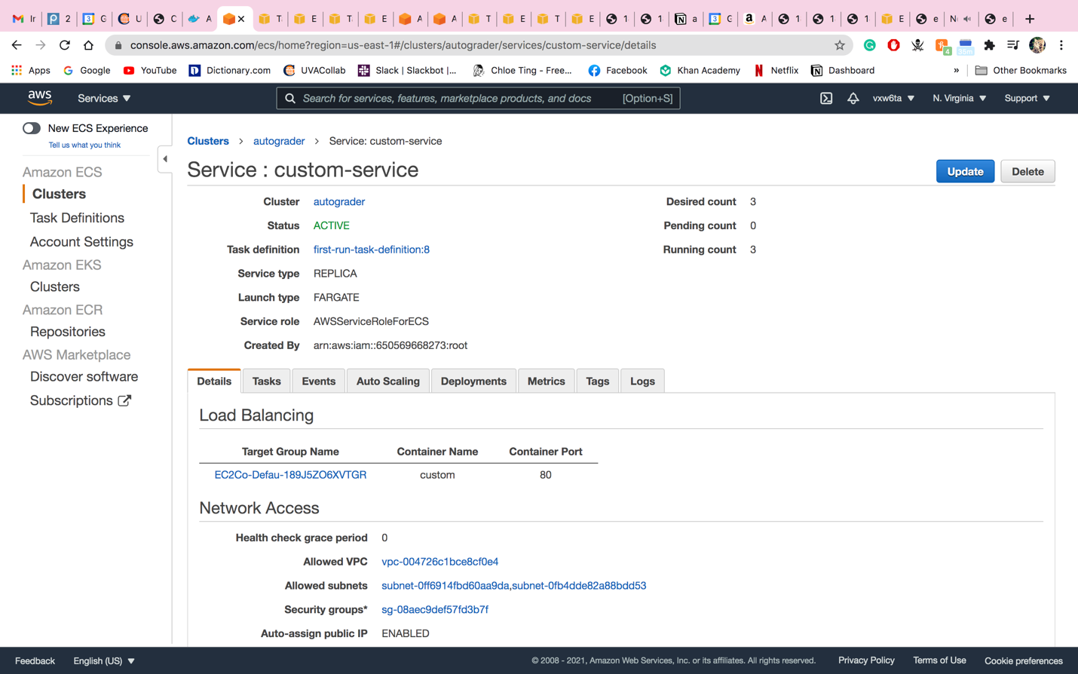

[b] the browser page (7” wide) to your Elastic Container Service-based student submission portal, and

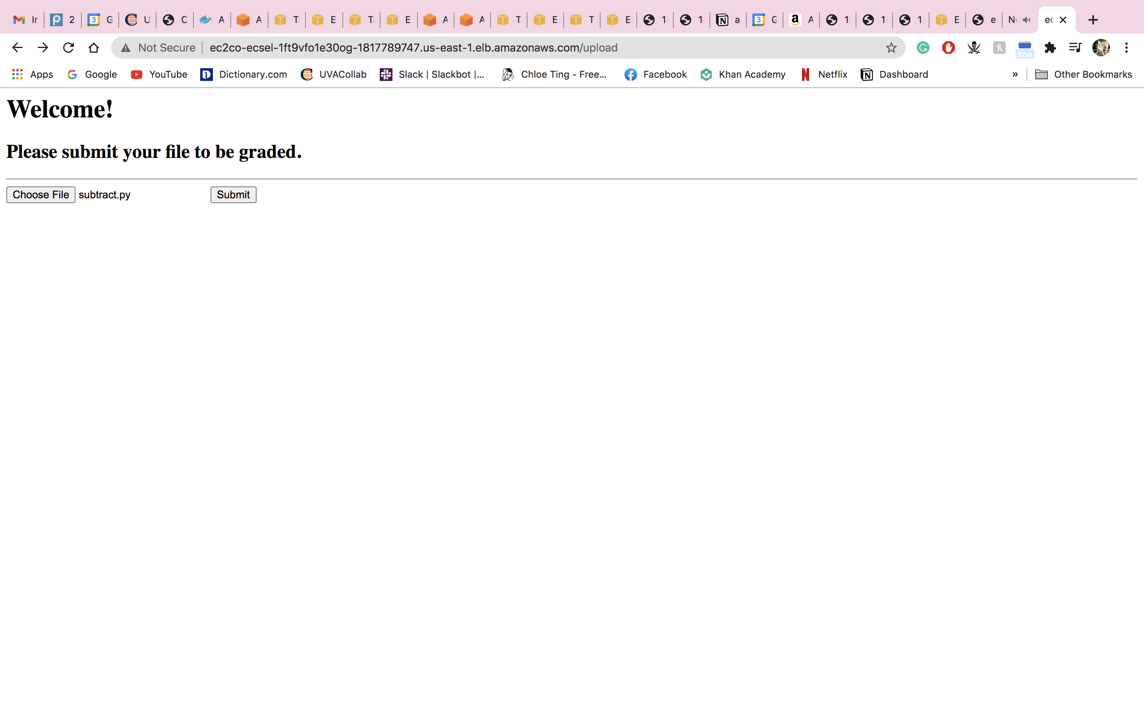

[c] the browser page (7” wide) to your Elastic Container Service-based results page (after a student submission has been auto-graded). You must show the URLs in the pictures.

